10/12/2022

ICT Lab 08

Abdullah Shafiq

22k-4489

**TASK 01**

Make Employee Table and insert given data.

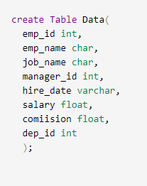

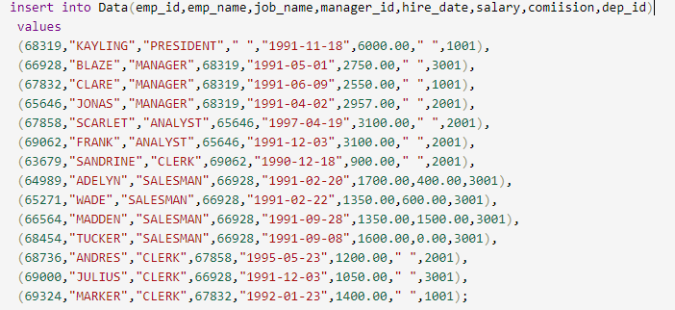

**TASK 02**

Fetch all data where job name is manager.

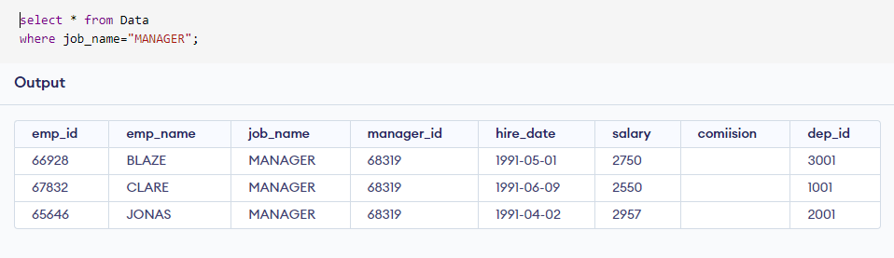

**TASK 03**

Arrange data is ascending order by salary if manager id is 66982.

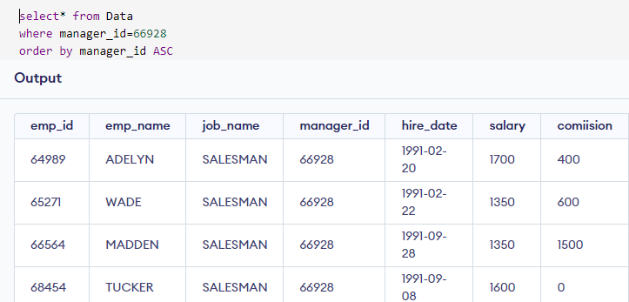

**TASK 04**

Change table name Employee to Company_data.

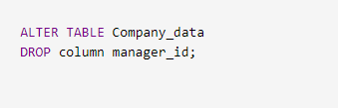

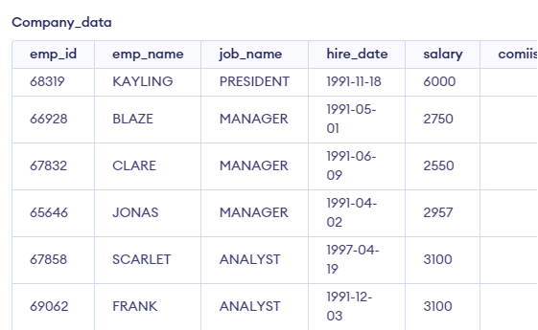

**TASK 05**

Delete manager_id column.

